FY2026-2027

Community Development Block Grant
HOME Investment Partnerships Program

General Rules & Guidelines
for Funding Applications
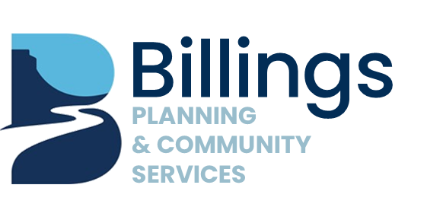
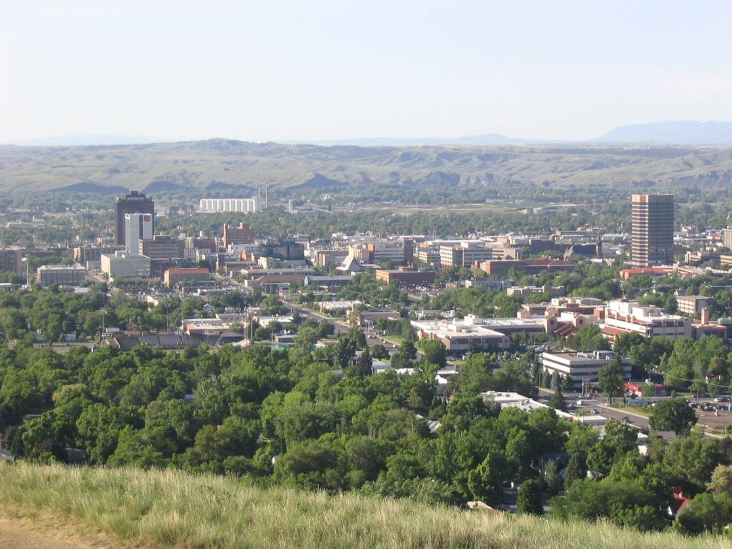
Housing & Community Development Funding Guidelines

City of Billings
Community Development Division
PO Box 1178
Billings, Montana 59103

www.BillingsMT.gov/ComDev

Housing Developers should refer to the City’s
Affordable Housing Development Program
for guidance on preparing funding applications specific to housing development.

The Affordable Housing Development Program
has separate guidance and application documents for new construction, acquisition, infrastructure, rehabilitation, and demolition activities
to support the development of multi-family, single-family and mixed-use affordable housing.

The processes outlined herein are specific to general applications,
including the City’s application to establish funding through federal resources
for the Affordable Housing Development Program.

All Community Development materials can be made available
in specialized formats upon request.
Table of Contents

Section I: Important Dates 4
Section II: Introduction 5
City Council Interests 5
Consolidated Planning & Allocation Processes 5
HUD’s Consolidated Plan Goals 6
Significant Aspects of the Process 6
Community & Neighborhood Task Force Involvement 6
Public Comment Period 7
Applicant Presentations to Neighborhood Task Forces 7
Budget Allocation Process 8
Budget Allocation Process Flowchart 9
Consolidated Plan Strategies 10
Section III: Federal Requirements 11
Low-Income Individuals / Households 11
Income Guidelines Chart 11
Low-Income Areas 11
HUD Requirements for Subrecipient Agreements 12
Performance Measurements 14
Quarterly & Annual Reporting 14
Monitoring 15
Section IV: Activity & Application Guidance 16
Eligible Applicants 16
Applications Initiated by Task Forces 16
Location & Residency 16
Timeliness 16
Leveraged Funding 16
Funding Types & Sources 17
Funding Objectives, Budget, Eligible & Ineligible Activities Chart 18
Section V: CDBG Guidelines 19
CDBG Major Funding Areas Chart 19
Administration Guidelines 19
Housing & Neighborhood Guidelines 20

Section VI: HOME Guidelines 21
Home Major Funding Areas Chart 21
Section VII: Application Submission 22
Application Format & Accompanying Documentation 22
Application Deadline, Completeness & Signature 22
Technical Assistance 22
Mandatory Subrecipient Meeting 22
Section VIII: Awards, Reports & Agreements 23
Neighborhood Task Force & Low-Income Areas Map 24

SECTION I - Important Dates
All meetings are open to the public and participation in Community Development Board meetings, City Council Work Sessions, and public hearings is encouraged.
Event | Date / Time / Location
Application Released | Friday, December 5, 2025  Online Applications available  www.BillingsMT.gov/CDapplication
Application Deadline | Friday, January 16, 2026, 5:00pm MST  Late applications will not be accepted
Community Development Board - Public Hearing  Applicants present proposed projects to the Community Development Board during their monthly meeting | Tuesday, February 3, 2026, 3:00pm  316 North 26th Street, Billings, Montana 59101
Annual Action Plan Public Comment Period  Drafted Annual Action Plan will be posted online at www.BilingsMT.gov/ConPlan | March 14 through April 13, 2026  Written comments may be submitted to beckettb@BillingsMT.gov
City Council Meeting - Public Hearing  Recommendations Presentation  Billings City Council Agendas | Monday, April 13, 2026, 5:30pm  Council Chambers, City Hall  316 North 26th Street, Billings, Montana 59101
City Council Meeting - Action  Annual Action Plan & Budget  City Council Agendas | Monday, April 27, 2026, 5:30pm  Council Chambers, City Hall  316 North 26th Street, Billings, Montana 59101
Beginning of Project Year | July 1, 2026  Subrecipient Agreements Finalized & Projects Begin
Expenditure Timeliness Deadline  Majority of awards must be expended by this date | April 1, 2027
Project Year End  for Housing & Neighborhood Activities | June 30, 2027
Please contact Brenda Beckett at 406-657-8286 or beckettb@billingsmt.gov for technical assistance on completing an application or additional information.

SECTION II - Introduction

Community Development Block Grant (CDBG) and HOME Investment Partnership (HOME) funds are made available to the City of Billings on an annual basis from the Federal Government through the U.S. Department of Housing and Urban Development (HUD). The CDBG Program was established in 1974. The primary objective of the program is the development of viable urban communities by providing decent housing, a suitable living environment, and expanding economic opportunities for low-income individuals. The HOME Program was established in 1992 to expand the supply of affordable housing, and the City of Billings became a participating jurisdiction in 1994.
Please note: HUD has not released budget levels as of the time of application release. Budget projections for the FY2026-2027 year in CDBG and HOME maintain level funding amounts from last year’s budget, making the total anticipated budget approximately $950,000 for both programs.
Impact of Limited Funding & Long-Term Sustainability: To accommodate historically low funding levels, the Community Development Board has previously implemented priority budgeting resulting in program elimination / drastic reductions. In FY2012-2013, the Community Development Board and City Council eliminated grant programs for non-profit organizations, opting for sustainable programs creating program income through City-managed loans.
Therefore, the City is not accepting applications from non-profit organizations for grants. Applicants can propose loan terms to meet project and activity needs. City staff generates applications for core programs including required affordable housing programs, home buyer / repair programs, infrastructure, and support for the Billings Metro VISTA Project to meet HUD’s poverty strategy requirements.

City Council Interests
The Billings City Council is interested in funding applications demonstrating applicant match funding commitments that address:
- Family Justice and Domestic Violence
- Crime Prevention Through Environmental Design in Low-Income Neighborhood Parks
- Infrastructure and Affordable Housing Development

Consolidated Planning & Allocation Processes
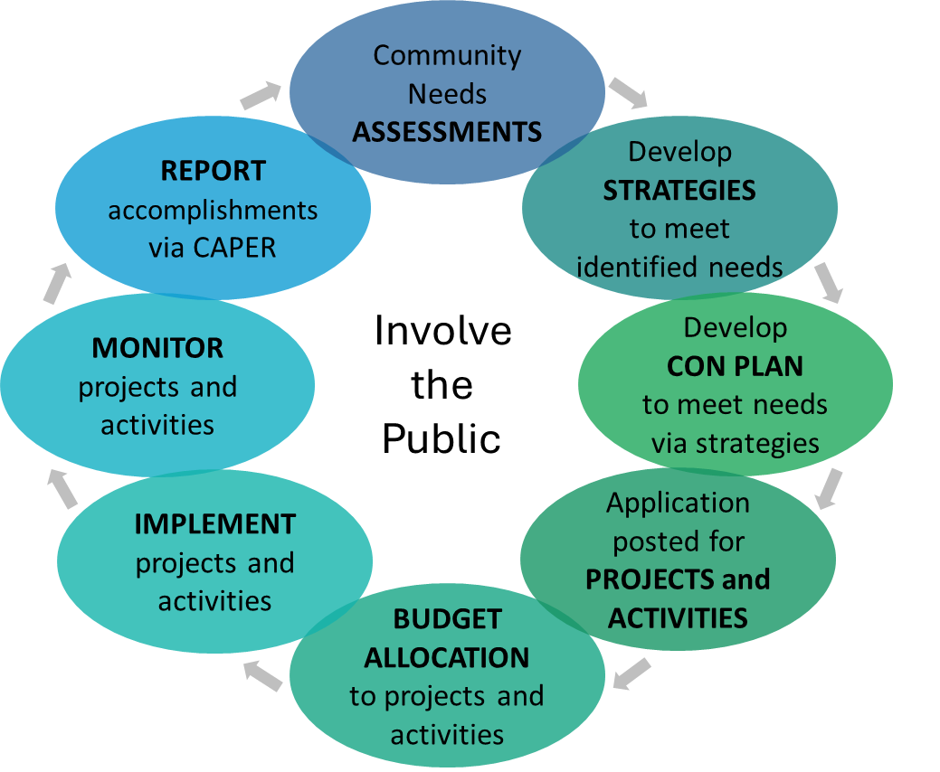
The purpose of the Consolidated Planning process is to identify the housing and community development needs of low-income households in Billings and develop strategies for addressing those needs in a comprehensive, coordinated fashion utilizing available federal and nonfederal resources.
Consolidated plans are developed every five years and must be submitted to HUD not less than 45 days prior to the start of the grantee’s program year start date (July 1). The City’s last five-year Consolidated Plan for FY2025-2029 identifies activities to be carried out from July 1, 2025 through June 30, 2030 to address priority needs in the community and serves as a guiding document for the use of the City’s CDBG Program and HOME funding.
The Consolidated Plan includes integrated priorities identified through a Needs Assessment and Housing Market Analysis. The development process also includes input from neighborhood groups and public hearings on housing and community development needs, relative to findings from available data sources.

The City’s latest one-year Annual Action Plan identifies goals, strategies, activities and funding sources to be undertaken and utilized from July 1 through June 30. The City must also report on the performance of activities funded via the Comprehensive Annual Performance Evaluation Report (CAPER) in September of each year.

HUD’s Consolidated Plan Goals
Focused on CDBG and HOME activities, the Consolidated Plan combines the planning and application requirements for the CDBG and HOME Programs. Consolidation of the submission requirements for the CDBG and HOME Programs allows program planning and citizen participation to take place in a comprehensive context covering both programs. The CDBG and HOME programs covered by the Consolidated Plan have three basic goals:
- To provide decent housing, including maintaining affordable housing stock in the community, increasing the availability of permanent housing that is affordable to lower-income households without discrimination, increasing support of housing which enables those with special needs to live independently, and assisting homeless people to obtain affordable housing.
- To provide a suitable living environment, which includes improving the safety and livability of neighborhoods, increasing access to quality facilities and services, reducing the isolation of income groups within areas by de-concentrating housing opportunities and revitalizing deteriorating neighborhoods, restoring and preserving natural and physical features of special value for historic, architectural, or aesthetic reasons, and conserving energy resources.
- To expand economic opportunities, including creating jobs accessible to lower-income individuals, providing access to credit for community development activities which promote long-term economic and social viability, and empowering lower-income those living in federally assisted and public housing to achieve self-sufficiency.

All activities undertaken by the City utilizing CDBG and HOME funding must primarily benefit low-income persons. The strategies described in the Consolidated Plan outline a specific course of action for the community’s housing and community development activities. The plan builds on local assets to meet the needs of the community and sets forth goals, objectives, and performance measures to ensure progress in achieving the strategies described in the plan.

Significant Aspects of the Process
The City utilizes significant public comment processes and coordinates input from various organizations and groups to maximize collaborative efforts while developing and implementing the Consolidated Plan. Both the Needs Assessment and Housing Market Analysis are utilized by City staff as primary planning tools for the development and implementation of Consolidated Plan activities.

Community & Neighborhood Task Force Involvement: The City of Billings makes special provisions for the involvement of the public, including seven established Neighborhood Task Forces: North Park; Central - Terry; South Side; Southwest Corridor; North Elevation; West End; and Billings Heights. A Neighborhood Task Force map is located on the last page of this guidebook.

Public Comment Period: A formalized public comment period is held for no less than 30 days, and various community groups are visited during this time to garner feedback on studies, plans and activities. Agenda items are also scheduled for a City Council Work Session and regular City Council meeting; the latter includes an additional, specific public hearing to review the Consolidated Plan and activities. All meetings are open to the public, advertised in the regionally distributed Yellowstone County News newspaper. Agendas offer a specific time for additional public comment.

Applicant Presentations to Neighborhood Task Forces: Organizations applying for funding that will benefit a particular or multiple Neighborhood Task Forces should plan on making informational presentations to Task Forces prior to application submission.
If multiple Task Forces are impacted by the proposed project or activity, the applicant may consider attending an Adjacent Neighborhood Committee meeting. Meetings are held quarterly either virtually or at City offices. Applicants can contact Wyeth Friday at 406-657-8249 or via email at fridayw@billingsmt.gov to be placed on the agenda for a presentation.

Task Force | Contact Information | Address
Central Terry  3rd Thursday at 7pm  January, April, July, and October | billingscentralterrytaskforce@gmail.com | Topline Hair  1331 Central Avenue
Heights  4th Tuesday of each month at 7pm | David Redmon billingsheightstaskforce@gmail.com | Oasis Conference Room  543 Aronson
Midtown Community Collaborative  2nd Tuesday of the month | mccbillingsmt@gmail.com | 1234 Avenue C
North Park  1st Wednesday of each month at 7pm | Thom Greenwood  thom@simonsenarchitect.com | North Park Community Center  North Park
Pioneer Park  2nd Tuesday at 6:30pm  January, April, July, and October | Anna O’Donnell  pioneerparkntf@gmail.com | Black Dog  3115 10th Avenue North
Rimrock Neighborhoods  3rd Wednesday  May, July, September, and November | Leslie Cooke  rimtophood@gmail.com  ldmcooke@hotmail.com | Mayflower Congregation Church  2940 Poly Drive
South Side  3rd Thursday of each month at 6:00pm | Lisa Vance  Southsidetaskforce@gmail.com | Walla Walla University Auditorium  2520 5th Avenue South
Southwest Corridor  Not Currently Meeting | Kevin & Lori Nelson  ljfatouros@gmail.com | N/A
West End  3rd Tuesday every other month at 7pm  January, March, May, July, September, November | Steve Zeier  billingswetf@gmail.com | Connections Church  56th Street West

Budget Allocation Process: City staff and the Community Development Board begin preparing for the grant allocation process each October. Applications are generally available at the beginning of December and are due in mid-January. The Community Development Board may conduct applicant site visits to review each application with the staff involved. In addition, City staff visit each of the seven Neighborhood Task Forces to garner housing / neighborhood activity rankings prior to the public comment period. Final recommendations are forwarded to the City Council for action each April and a public hearing is held to receive comments. The Annual Action Plan is then submitted to HUD for approval by May 15.
The Budget Allocation Process flowchart (following page) illustrates the significant aspects of public involvement and input processes utilized for Consolidated Plan development and implementation. All plans and studies are posted on the City’s website, and emails are distributed announcing application and Consolidated Plan postings.

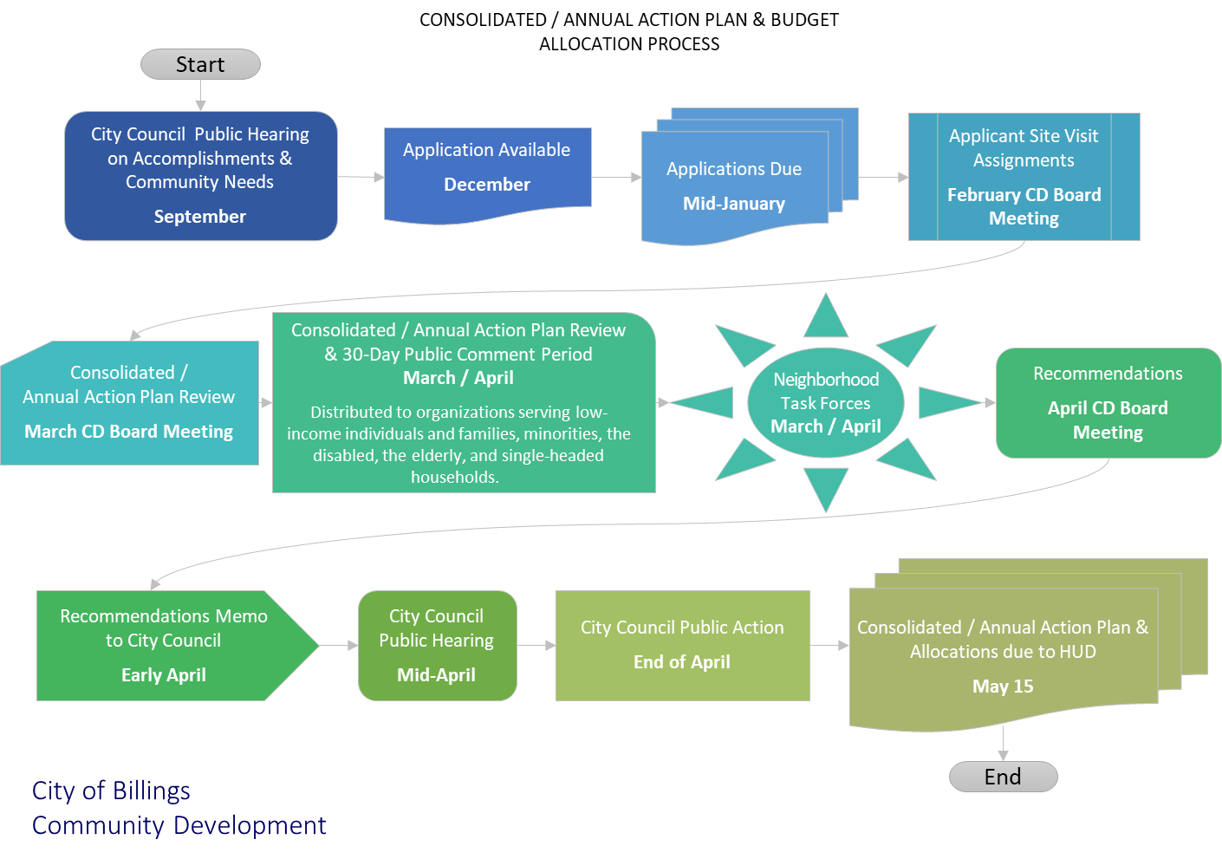
Consolidated Plan Goals, Strategies, and Key Initiatives
Activities must be designed to address one or more of the strategies and goals of the City’s Consolidated Plan to: create, preserve, and expand affordable housing options; promote neighborhood revitalization through foreclosure program; impact poverty; and prepare, prevent, and respond to the coronavirus pandemic. The City will continue to offer programs on a citywide basis to ensure equal opportunity in all Billings neighborhoods.

Affordable Housing
Goal: Create, preserve, and expand decent, affordable housing options for low-income residents citywide. Community Development aims to enhance and broaden housing access, availability, physical quality, economic value, and longevity across the city for Billings’ low-income residents including seniors, individuals with disabilities, minority groups, and other special populations.
Strategy: Increase affordable housing opportunities by implementing financing initiatives, including housing development loans to drive construction and rehabilitation, first-time homebuyer loans to support sustainable ownership, and home repair financing to preserve and upgrade existing low-income neighborhood homes.
Key Initiatives
- Affordable Housing Development: Promote citywide development of affordable single-family, multi-family, and special needs housing by offering loan financing to private developers and nonprofit organizations for new construction, rehabilitation, and infrastructure improvements.
- First Time Home Buyer: Offer accessible loan financing to foster first-time homeownership opportunities that support long-term financial stability, build generational wealth, and stabilize neighborhoods.
- Home Repair: Offer loan financing to agencies that assist low-income homeowners in completing essential repairs - such as major systems upgrades, weatherization, energy/water efficiency, and lead water service line replacements - to enhance and preserve the quality of Billings' affordable housing stock.
- Foreclosure: Mitigate the adverse effects of vacant, foreclosed properties by acquiring, rehabilitating, and selling these homes to low-income households - thereby combating urban decay, reducing crime, stabilizing property values, and stimulating the local economy.

Services for Vulnerable Populations
Goal: Ensure that vulnerable populations have reliable access to comprehensive supportive services that enhance stability, self-sufficiency, and overall well-being.
Strategy: Provide resources to nonprofit organizations to address poverty and provide supportive services to low-income individuals and families to provide stable housing, promote self-sufficiency, and promote overall well-being:
Key Initiatives
- Public Facilities: Provide financing to develop public facilities to serve as accessible, community-based hubs where individuals and families facing economic, social, or health-related challenges can find help.
- Billings Metro VISTA Project: Allocate AmeriCorps resources to nonprofit organizations to undertake poverty impact activities and to support the low-income individuals and families they serve. Federal AmeriCorps Volunteers in Service to America (VISTA) focus areas include education, healthcare, food security, economic opportunity, housing, financial literacy, and others.
- HOME-ARP: Provide grant funding to nonprofit organizations delivering supportive services to prevent homelessness; unhoused individuals and families; those at-risk of becoming unhoused; and people fleeing domestic violence/trafficking. Federal service categories include case management, housing counseling, rent/utilities/deposit assistance, mental health/healthcare, substance misuse treatment, job training, employment, financial literacy, assistance with benefits enrollment, childcare, and transportation.

Neighborhood Revitalization
Goal: Foster suitable living environment and quality of life through the improvement of physical conditions in lower-income neighborhoods.
Strategy: Integrate environmental design, infrastructure improvements, and public safety measures to revitalize neighborhoods, prevent crime, and enhance quality of life for residents.
Key Initiatives
- Crime Prevention Through Environmental Design: Reduce crime by making infrastructure improvements in low-income neighborhoods (parks, adding streetlights, etc.) while: creating more attractive and secure environments; stimulating local investment; encouraging residents to use public spaces more freely; and improving quality of life for low-income residents.
- Lead-Pipe Water Line Replacement: Provide affordable loan financing to low-income homeowners to remove lead pipes from the property line to residences to prevent lead poisoning, improve water quality, and promote neighborhood health and public safety.

SECTION III - FEDERAL REQUIREMENTS

A variety of regulations apply to the use of CDBG and HOME funds. All requirements must be considered prior to when applications for funding are submitted to ensure the applicant has the capacity to manage and properly report on the use of federal funding.

Low-Income Individuals / Households
The City defines low-income individuals / households as individuals or households with incomes at or below 80% of the median income (see chart below). One of the key provisions of the CDBG and HOME Program regulations is that most activities or services provided must principally benefit lower-income individuals, and such benefit must be documented. Elderly and disabled individuals are automatically considered lower income if assisted under a public service activity. However, demographic information must be provided on all beneficiaries, regardless of presumption of eligibility.

2025 INCOME GUIDELINES
Income limits are established by HUD and are reviewed each year, resulting in expected changes each March / April.
Size of Household | Extremely Low  Up to 30% | Very Low  31% - 50% | Low Income  51% - 80%
Size of Household | Extremely Low  Up to 30% | Very Low  31% - 50% | 51% - 60% | 61% – 80%
1 | $20,450 | $34,000 | $40,800 | $54,400
2 | $23,350 | $38,850 | $46,620 | $62,200
3 | $26,250 | $43,700 | $52,440 | $69,950
4 | $29,150 | $48,550 | $58,260 | $77,700
5 | $31,500 | $52,450 | $62,940 | $83,950
6 | $33,850 | $56,350 | $67,620 | $90,150
7 | $36,150 | $60,250 | $72,300 | $96,350
8+ | $38,500 | $64,100 | $76,920 | $102,600

All successful applicants will be required to maintain income data, racial / ethnic characteristics, and head-of-household status and other demographic information for all individuals receiving services under a CDBG or HOME funded project. Organizations receiving funding will complete a subrecipient agreement with the City and be monitored on site by Community Development staff.

Low-Income Areas
Lower-income neighborhoods are areas where at least 51% of the households are lower-income as determined by Census data. A map identifying areas in Billings based on the Census, which are considered low-income under the terms of the City's Community Development Division, is included on the last page of this guidebook. Outlined areas on the map are low-income neighborhoods. To qualify as a low-income area, at least 51% of the residents of the neighborhood must be low-income, which is defined as individuals whose income is less than or equal to 80% of the median income for the city. Neighborhoods, which qualify as a low-income area, are eligible for certain neighborhood improvement activities undertaken with Community Development funds. To learn more about demonstrating area benefits to low-income residents, please reference this instructional video published by HUD.

Low-income neighborhoods must be primarily residential in character, and improvements in low-income areas must primarily benefit low-income residents of the area. For example, improvements to a commercial area located in a low-income area that is primarily commercial would not be eligible as a low-income benefit activity. Improvements to a facility in a neighborhood which does not primarily serve the low-income neighborhood (but rather serves the city as a whole) such as Dehler Park located in the North Park Task Force Neighborhood would not be eligible. Applicants must demonstrate projects primarily serve low -income neighborhoods and can demonstrate this through gathering beneficiary data.

Areas in Billings that qualify as low-income for Community Development activities continue to include the North Park and South Side Task Force Neighborhoods, and parts of the Central-Terry Task Force Neighborhood. Other areas eligible are the North Elevation Task Force and portions of the Southwest Corridor, Billings Heights, and West End Task Force neighborhoods.

HUD Requirements for Subrecipient Agreements

Organizations receiving funding approval from the City Council will be required to enter into a written agreement with the City of Billings covering (but not limited to) the following items:
1. Statement of Work & Budget: The agreement shall describe each task to be undertaken, including a schedule for completing each task. It shall also include a budget indicating the amount of CDBG / HOME funds allocated to each task described in the statement of work. The statement of work and budget shall be in sufficient detail to provide a sound basis for the City to effectively monitor performance under the agreement.
2. Records & Reports: The following records and reports must be maintained and submitted to the City of Billings to assist the City in meeting its record keeping and recording requirements:
Equal Employment Opportunity: Information on the percentages of women and minorities employed.
National Objective: Information showing compliance with the national objective of benefiting low-income individuals or areas. Public service activities must document that the individuals benefiting from CDBG funds are low-income in the application, and reimbursements will only be made for services rendered to individuals residing and receiving services within the city limits.
3. Program Income: Treasury Circular 1075 requires that cash advances to a recipient organization shall be limited to the minimum amounts needed and shall be timed to be in accord only with actual, immediate cash requirements of the recipient organizations in carrying out the purpose of the approved project or program. This requirement prevents the City from advancing funds to Subrecipients. As such, all requests for payment by a Subrecipient will be on a reimbursement basis.
4. Other Program Requirements: The organization will be required to conform to the following Federal Laws as applicable:
Fair Housing: Affirmatively furthering fair housing (Public Laws 88-352 and 90-284, Executive Order 11063).
Discrimination: Section 109 of the Housing and Community Development Act prohibits discrimination on the grounds of race, color, national origin, or sex in the uses of federal funds. In addition, discrimination on the grounds of creed is prohibited in Montana. HUD also prohibits discrimination due to sexual orientation and gender identity for all federal programs.
Labor Standards: Davis-Bacon Wage Rates applies to construction work of more than $2,000 or if assistance is requested to support eight or more housing units for CDBG projects. For HOME projects, Davis-Bacon Wage Rates applies to projects requesting assistance for 12 or more housing units. Projects involving volunteer labor only may be exempt from Davis-Bacon if the individual volunteers for the work and does not receive compensation for any work provided on-site for the project.
Environmental Standards: The City of Billings will assume responsibility for completing the environmental review requirements for each CDBG / HOME assisted activity. This process generally takes 45-60 days to perform the review, publicize notices, and allow for review and comment period.
Employment and Contracting Opportunities: Subrecipient organizations will be required to comply with Executive Order 11246 prohibiting discrimination in employment on federally assisted construction contracts and Section 3 of the Housing and Urban Development Act of 1968 requiring, to the greatest extent feasible, employment opportunities for low-income residents and/or residents from lower-income areas.
Lead-Based Paint: The use of lead-based paint is prohibited and rehabilitation work on residential structures built prior to 1978 must be conducted according to HUD regulations on lead-based paint. Title X, the Residential Lead-Based Paint Hazard Reduction Act, was passed in 1992.
Use of Debarred, Suspended, or Ineligible Contractors: CDBG funds cannot be used to employ debarred contractors. A determination of the eligibility of a contractor to perform work on a City-assisted project may be obtained from the Community Development Division.
Uniform Administrative, Cost Principles and Audits: Organizations will be required to comply with the policies, guidelines, and requirements of the Uniform Administration, Cost Principles and Audit requirements set forth in 2 CFR Part 200.
Conflict of Interest: No person who is an employee, grant consultant officer, elected official, or appointed official to the City or of any public agency receiving funds, who exercises and functions or has responsibility with respect to City funds or who are in a position to participate on a decision-making process or gain inside information with regard to such activities, may obtain a personal financial interest or benefit from the activity, or have an interest in any contract with respect thereto, or the proceeds there under, either for themselves, or those with whom they have family or business ties during their tenure or for one year thereafter.
Prohibition Regarding Displacement of Lower-Income Households: Displacement is generally not applicable to public service activities. All projects funded with CDBG and HOME funding are subject to this prohibition.
5. Reversion of Assets: The agreement shall specify that if an organization ceases to use any assets acquired with CDBG funds for the purpose described in the agreement, the subrecipient shall either pay to the City the fair market value of the asset or transfer control of the asset to the City.
6. Religious Organizations (Special Conditions): Affiliated with religious organizations that are performing activities which have been determined by HUD to be free from sectarian influences will be required to agree to HUD's "Special Conditions for Religious Organizations."

Performance Measurements
In October 2006, HUD began to require additional performance measurements for all CDBG / HOME awardees that includes the identification of objectives and expected outcomes of the project or activity. The application has been updated to include performance measurements. Public Service activity outputs are typically measured by the number of low-income persons affected by the activity. Housing and Neighborhood activity outputs can be measured by the number of housing units or households, number of people assisted, or number of businesses assisted / expanded. The City’s application process for funding through these programs includes identification of HUD objectives and outcomes to ensure compliance with activity requirements.

HUD PERFORMANCE MEASUREMENTS
Objectives | Outcomes
Suitable Living Environment | Availability or Accessibility
Decent Housing | Affordability
Economic Opportunities | Sustainability

Quarterly & Annual Reporting
All activities funded by the City must illustrate measurable results because of federal funding investment. Different types of activities have different forms and data fields for reporting.

Client Data Reporting: Beneficiary data must be gathered on all clients and households served with federal funding, and submitted on a quarterly basis to the Community Development Division:
- Client Data Form: Optional form to be used by Subrecipients if they do not have a system in place to garner income, ethnicity, race, and other demographic data. Please ensure the organization is utilizing the current year’s income guidelines. New guidelines are typically published by HUD each spring.
- Direct Benefit Summary Data - Quarterly Report: Required for all projects until funding is fully drawn.

Requests for Reimbursement: Requests may be made on a quarterly basis to reimburse funded activities. This report must be accompanied by the Direct Benefit Summary Data - Quarterly Report.

Equal Employment Opportunity Practices: Guidance is provided to meet compliance with Section 3 and equal opportunity regulations for positions supported (either in part or in full) with federal funding. Recruitment efforts must include targeting to reach low- and very low-income individuals, and race / ethnicity documentation must be provided on applicants for any positions supported by federal funding.
- Grantee Employment Summary: Form to be used when a position, supported by federal funds, is being advertised / filled.
- Interview and Hiring Form: Form must be used to document demographic information. If the form is not filled out by the employment applicant, it must be filled out by the interviewer based on observation only.
- Applicant Summary Sheet: List all applicants for federally supported positions.

Year-End Reporting: Reports are due by July 31 of each open activity year. For example, if a Subrecipient fully expended CDBG Public Service funding the first year, annual reports are still due for years one through three for the entire activity period. Outcomes on annual reports must match quarterly report totals.
- Annual Report - Public Services: Report to be utilized for all CDBG Public Service (social service) activities; must be reported in number of INDIVIDUALS (not households) served with the project.
- Annual Report - Housing & Neighborhood: Report to be utilized for all HOME and CDBG Housing & Neighborhood Activities. Outcomes must be reported on HOUSEHOLDS, not individuals.
- Annual Audit Report: This report must be submitted by all Subrecipients, including Public Service and Housing and Neighborhood activities.

Monitoring

The City of Billings is required by HUD to conduct on-site monitoring of subrecipient organizations receiving CDBG funds to assure compliance with CDBG regulations. All organizations will receive advance notice of the scope and timing of the monitoring visit.

SECTION IV - ACTIVITY & APPLICATION GUIDANCE

Eligible Applicants
Any individual, non-profit organization, business, or governmental agency may apply for CDBG / HOME funds. Applicants must follow all federal, state, and local laws / regulations. Neighborhood Task Forces may initiate an application, but must work through a City department if the activity involves improvements to parks, streets, etc.

Applications Initiated by Task Forces: Neighborhood Task Forces are required to submit applications by the January deadline so that all Task Forces and other organizations can be made equally aware of the applications submitted. Task Forces are encouraged to prioritize neighborhood needs on a multi-year basis. Technical assistance via Community Development staff is available to Task Force officers to develop and present a neighborhood initiative for consideration by the Community Development Board.

In 2005, the City Council implemented a policy regarding the generation of applications via City staff for projects involving publicly owned land, including projects identified for funding through the City’s Capital Improvement Plan (CIP). If improvements to a neighborhood park are prioritized by a Neighborhood Task Force, the officers of the Task Force should contact the Parks & Recreation Department directly. City staff members are familiar with the application process for Community Development funding, and they must generate the application for funding on publicly owned land. Likewise, infrastructure projects (streets, sewer / water, etc.) involving publicly owned land must be generated through the Public Works Department. Projects involving improvements funded additionally by the CIP must refer to the amount and year of funding already committed via the CIP.

Location & Residency
Activities must be located within the Billings city limits or demonstrate that most of the clients served reside within the City of Billings. If awarded funds, requests for reimbursement can only be submitted for clients residing AND receiving services within the City of Billings limits.

Timeliness
The Department of Housing and Urban Development (HUD) requires that the City of Billings expend CDBG / HOME funds in a timely manner. Projects will be evaluated and prioritized based on timely expenditure of funds. Funding not expended within project timelines will be reallocated.

**PLEASE NOTE: Priority is given to organizations that can expend funds by April 2027 to assist the City in meeting HUD’s timeliness deadlines.** Organizations seeking support for projects that cannot expend funds by this upcoming April should wait until the project is ready for implementation to apply.

Leveraged Funding
Projects requiring additional funding should generate most project funding commitments prior to an application being submitted through Community Development. The Community Development Board prioritizes projects with high leveraged funding ratios and generally advises applicants to come to the Board for final funding amounts to complete a financing package for the project, rather than coming to the Board for initial funding in hopes other funding will be generated in the future. This practice ensures the City will not encumber funds that will jeopardize the timely expenditure of funding, as mandated via federal regulation. Funding not committed and expended in a timely manner is subject to recapture by HUD.
Funding Types & Sources
CDBG and HOME funding can provide financial assistance to support strategies identified in the Consolidated Plan. Both funding sources have limitations on what types of activities can be funded.

Please note: Final federal allocation amounts may not be determined until April, or even later, each year. Preliminary budget figures are offered in these guidelines but may change due to federal actions. Application awards are contingent on federal appropriations and funding awarded may be less than estimates presented in this document.

Funding Objectives, Budget, Eligible & Ineligible Activities
Primary Objectives | CDBG | HOME
Primary Objectives | The development of viable urban communities by providing decent housing, a suitable living environment and expanding economic opportunities principally for low-income citizens.  Must meet one of the following national objectives:  - Benefit lower-income households; OR  - Result in the prevention or elimination of slums or blighted conditions. | Please note: Most of the HOME funding is typically used for housing development. Funding applications for housing development are located online at www.BillingsMT.gov/CHDO.  Provides coordinated financial assistance in the development of affordable, low-income housing.  Expands the supply of safe and sanitary affordable housing for low-income residents in Billings.  Strengthens the ability of local governments and other housing development entities to actively participate in community housing enhancements.
Budget Estimates | - CDBG New Entitlement Funding: $650,000  - Program Income: $100,000  - Total CDBG Estimate: $750,000  - Administration Cap (Maximum 20%*): $130,000  - Public Service Cap (Maximum 15%*): $97,500 | - HOME New Entitlement Funding: $300,000  - Program Income: $100,000  - Total HOME Estimate: $450,000  - Administration Cap (Maximum 10% of New Entitlement*): $30,000  - Community Housing Development Organizations (Minimum 15%* New Entitlement): $45,000
Eligible Activities | Housing & Neighborhood - Bricks & Mortar / Building Projects | Affordable Housing Projects  Applications online at www.BillingsMT.gov/CHDO
Eligible Activities | - Property Acquisition  - Disposition & Relocation  - Public Facilities & Improvements  - Clearance & Building Abatement  - Housing Rehabilitation & Home Repair  - Economic Development  - First Time Home Buyer Assistance | - New Construction of Housing Units  - Acquisition of property for immediate and eligible use, site improvements, & demolition activities related to new housing  - First-Time Home Buyer Assistance  - Construction of Transitional Housing Units
Eligible Activities | Public Services | Community Housing Development Organizations (CHDOs)
Eligible Activities | Public Service Eligible Activities:  Social Services  Purchase of Equipment  Fair Housing Education  Operation / Maintenance of a Public Facility or Improvement | Minimum 15% of Entitlement must be designated to CHDOs to implement housing activities, including:  acquisition / rehabilitation / new construction  of rental & homebuyer units
Ineligible Activities | Improvement to Buildings Used for the General Conduct of Government, Political Activities, Income Payments, Religious Activities, and any activities or improvements the City of Billings already funds through alternative mechanisms. | Any activity that does not result in housing benefit that does not have a specific address to report. The City of Billings does not fund homeowner-occupied housing rehabilitation programs currently.
*Maximum / Minimum amounts are typically based on total budget. However, program income and budget allocations vary by category. For more information, contact Community Development staff.

SECTION V - CDBG GUIDELINES

Examples of CDBG projects funded in the past include the preservation and rehabilitation of the City's existing affordable housing stock through housing rehabilitation activities, funds to support down payment and closing cost assistance for first time homebuyers, funding of public service activities (up to 15%), Special Assessment Grants, and other public improvements which benefit low-income areas.

Traditionally, both nationally and in Billings, CDBG funds have been used to fund bricks and mortar improvements such as housing rehabilitation, park improvements, and other public facility improvements. In 1984, the CDBG Program was amended by HUD and the cap on funding to public service activities was set at 15%. Funding for public service activities is intended to complement low-income neighborhood revitalization efforts.

**Please note: Priority is given to organizations that can expend funds by Apri. 2027 to assist the City in meeting HUD’s timeliness deadlines.**

CDBG Major Funding Areas
Categories | Administration | Housing & Neighborhood  Bricks & Mortar LOAN Projects
Budget Limitations | Maximum 20% of CDBG | Approximately 65% of CDBG
Project Term | One Year | One Year
Funding Request Limits | None | None
Estimated # of Awards | One | Two - Three
Project / Activity Examples | Housing Needs Assessment | Housing Rehabilitation Programs
Project / Activity Examples | Assessment of Fair Housing | Minor Home Repair Programs
Project / Activity Examples | Assessment of Fair Housing | Wheelchair Ramps
Project / Activity Examples | AmeriCorps VISTA - Public Service | Infrastructure

Administration Guidelines
The City typically applies for CDBG funds to facilitate administration to manage the program. Projects funded through this category include allocations to facilitate five-year studies required by HUD, including the Needs Assessment and Housing Market Analysis. Other projects include administration for the AmeriCorps VISTA project, which brings volunteers to Billings to facilitate capacity-building efforts to impact poverty / homelessness.

Housing & Neighborhood Guidelines
This category is reserved for projects that are considered “bricks and mortar,” or building projects. Projects requiring inclusion on the City’s Capital Improvement Plan (CIP) for additional City funding (infrastructure, parks improvements, etc.) must refer to the amount and year of funding already committed in the CIP. Funding must be expended within three years of allocation.

Please note:
- Projects located in a Task Force area with a completed Neighborhood Plan must comply with the neighborhood plan.
- Projects impacting City parks, facilities, programs, or functions must be coordinated with the appropriate City Department staff prior to application submission.

SECTION VI - HOME GUIDELINES

Funding from the HOME program must be allocated to support affordable housing activities for low- and very low-income individuals. Activities not involving affordable housing are not eligible. The City of Billings has historically funded the following overall programs through this annual allocation process:
- First Time Homebuyer Program - Funding for direct down payment and closing costs assistance is established through this program, which is managed by City staff.
- Community Housing Development Organizations (CHDOs) - A CHDO is a private nonprofit, community-based service organization whose primary purpose is to provide and develop decent, affordable housing for the community it serves. Guidance regarding CHDOs can be found online.
- Affordable Housing Development Program - This program assists in acquisition, demolition, rehabilitation, and new construction of housing units. City staff typically applies to fund this program utilizing the annual allocation process described herein. The funding application submitted by staff can include both CDBG and HOME funding, depending on the anticipated allocation from HUD.
  - Organizations and developers interested in pursuing an application through the Affordable Housing Development Program will be required to apply for funding through a separate application process. Detailed requirements and an application for this program are available online. There is no deadline to apply, and applications are considered on a first-come, first-served basis.
  - Applications from certified CHDOs will always receive priority consideration for funding for affordable housing development projects.

HOME Major Funding Areas
Categories | Administration | Housing Assistance | Community Housing Development Organizations (CHDOs)
Budget Limitations | Maximum 10% of HOME | Approximately 75% of HOME | Minimum 15% of HOME
Project Term | One Year | One Year | One Year
Funding Request Limits | None | None | None
Estimated # of Awards | One | One - Two | One
Project / Activity Examples | Housing Needs Assessment | First Time Homebuyer Program | Acquisition / Rehabilitation of Rental Housing
Project / Activity Examples | Analysis of Impediments to Fair Housing Choice | Tenant-Based Rental Assistance - no longer accepting applications in this category | New Construction:  - Rental Units  - Homeownership Units
Project / Activity Examples | General Administration Costs | Affordable Housing Development Program | New Construction:  - Rental Units  - Homeownership Units

SECTION VII - APPLICATION SUBMISSION

Application Format & Accompanying Documentation
A completed application includes the following components and must be submitted online in FULL by 5:00pm on the deadline date (see Section I, Important Dates) link to guidelines and application: www.BillingsMT.gov/CDapplication.
Submission must include:
- Completed and signed application | - Most recent agency audit / IRS Form 990
- Organization’s Board Member List | - Completed Project Budget & Summary
- Treasurer / Financial Report through December 31 | - If staff position funding is requested:  - Job Descriptions, Personnel Policies, Affirmative Action Policy
- Current Bylaws
- Articles of Incorporation

Application Deadline, Completeness & Signature
Applications must be submitted to the Community Development office by 5:00pm on the deadline date (see Section I, Important Dates). Please plan to be early with your submission. The Community Development Board will NOT consider late applications or applications submitted using earlier versions of the application document.
The applications and attachments must be complete and all requested information is attached. The Community Development Board will NOT consider incomplete applications. Non-profit organizations must have the chairperson of their Board of Directors sign the application to ensure the application has been authorized by their governing board.

Technical Assistance
Staff will be available to provide an overview of the application form and answer questions upon request.
You may also call B. Beckett at 406-657-8286, email at beckettb@billingsmt.gov, or make an appointment to visit in-person for assistance.

Mandatory Subrecipient Meeting
Awardees are required to attend a meeting to review Subrecipient Agreements, program requirements, reporting procedures, records management, monitoring procedures, etc. Individuals responsible for contract execution, reimbursement requests and quarterly reporting are required to attend.

SECTION VIII - AWARDS, REPORTS & AGREEMENTS

Please see Section I, Important Dates, for the dates the Community Development Board will finalize recommendations to present to the City Council, and for the date of City Council action regarding recommendations.

Process for Awards, Reports & Agreements

The process for executing contracts for CDBG and HOME funding includes the following:

Mandatory Subrecipient Meeting: Mandatory attendance to receive technical assistance on the Subrecipient Agreement, requests for reimbursement process and quarterly / annual reporting at the Subrecipient Meeting.

Environmental Review Record: Community Development staff completes the environmental review process for all awards.

Agreement Completion: Subrecipient completes the Subrecipient Agreement as instructed and provides a signed copy of the Agreement and project budget to the Community Development Division no later than July 31. The project budget does not have to include total organizational budget. Failure to comply with this deadline may result in funding reallocation to another project or organization.

City Signature: Subrecipient Agreement is routed to the City Administrator for signature.

HUD Authorization: Official authorization of the submitted Consolidated Plan received. Funds are not officially committed until this authorization is received.

Activities: Activities are carried out as per the CDBG / HOME Application and Subrecipient Agreement.

Quarterly Reports / Requests for Reimbursement: Quarterly requests for reimbursement are submitted, accompanied by progress report, receipts for reimbursement and data collected on individuals served / housing units generated:

July through September - report due October 31.

October through December - report due January 31.

January through March - report due April 30.

April through June - report due July 31.

Quarterly reports are mandatory while a balance of funds remains in the City accounts. After all funding has been expended, annual reports are submitted for three years to illustrate the results of capacity-building efforts. If CDBG funding is utilized for any part of a staff position, please be sure the report indicates other funds contribute to the salary / wage, amounts and percentages.

Annual / Audit Reports: Annual and Audit reports are due July 31 and include demographics and total number of clients served through the activity. Figures reported should match the total of the quarterly reports!

Monitoring: Subrecipients are monitored on an annual basis by the Community Development Division. This may include in-office and on-site reviews.

HUD has prepared a guide for CDBG Subrecipients (Playing by the Rules: CDBG Subrecipient Handbook) on the administrative requirements for receiving grants. Subrecipients are expected to review this manual for important information regarding implementing CDBG activities.
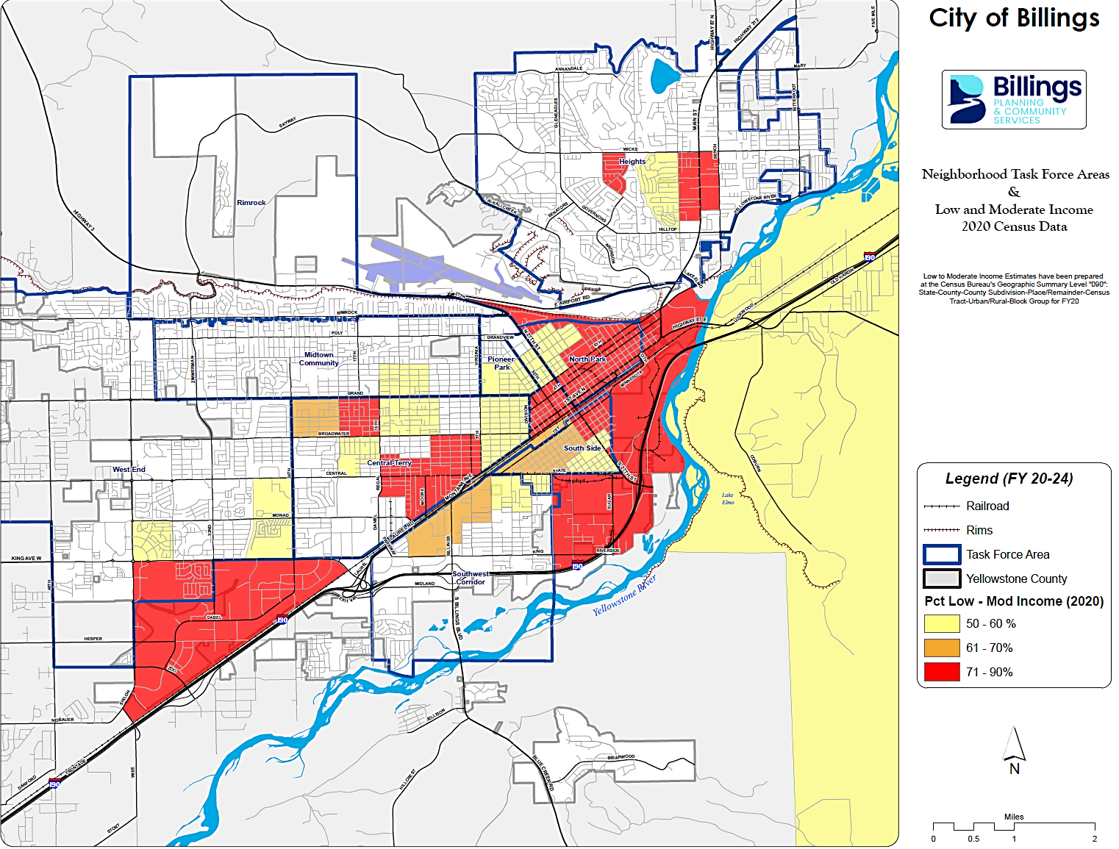

Income category naming standards vary by funding source. For example, CDBG defines ‘low income’ as ≤50% of the Area Median Income (AMI) and households with incomes ≤80% AMI are considered ‘moderate-income’. HOME defines ‘low income’ as ≤80% AMI.

